**Name: SRAVANI KANDI Student Id:12601230**

**Advance Virtual Reality CS6001**

**Project Title: DESTRUCTION OF HOUSES BY LIGHTENING**

**Project Description Submitted for Approval:**

**Abstract:**

1. In my final project for Advanced Virtual Reality, I'm focusing on simulating the destruction caused by lightning, thunderstorms, and strong winds within a residential area.
2. To achieve this, I'll be using various techniques to create realistic effects. For instance, I'll simulate rain using the Popnet node.
3. And implement lightning strikes that can trigger fires upon hitting buildings. These fires will spread dynamically using pyro nodes, leading to the destruction of nearby houses.
4. In addition to these visual elements, I'll be enhancing the immersive experience by incorporating sound effects. Using the audio panel taught in class, I'll recreate the booming sounds of thunder to further immerse the user in the intensity of the storm.
5. Expanding on the simulation, I'll aim to create severe thunderstorms by introducing tornadoes. These tornadoes will be simulated by applying wind effects to clouds, resulting in the destruction of surrounding huts due to the severe winds they bring.
6. Furthermore, I'll be enriching the natural ambiance of the scene by adding trees and applying realistic wind effects to them. This attention to detail ensures that users will have a truly lifelike and immersive experience as they witness the devastating power of nature in my project.

**References:**

* **In-Class Experiments/Lectures: Class- (table)**
* [https://www.sidefx.com/docs/houdini/nodes/sop/switch.html](https://nam02.safelinks.protection.outlook.com/?url=https%3A%2F%2Fwww.sidefx.com%2Fdocs%2Fhoudini%2Fnodes%2Fsop%2Fswitch.html&data=05%7C01%7Cskbg8%40mst.edu%7Ce47b784b705f4c63d3fc08dbf3796cd4%7Ce3fefdbef7e9401ba51a355e01b05a89%7C0%7C0%7C638371475060521027%7CUnknown%7CTWFpbGZsb3d8eyJWIjoiMC4wLjAwMDAiLCJQIjoiV2luMzIiLCJBTiI6Ik1haWwiLCJXVCI6Mn0%3D%7C3000%7C%7C%7C&sdata=SCnY2RM1beVcU7uLch%2Bmsszf5I05gYcSk3aJ3uPuOBM%3D&reserved=0)
* <https://www.youtube.com/watch?v=tQfoBAJpnDo&t=84s>
* <https://www.youtube.com/watch?v=EOVNfkFs1CM> -Building construction
* <https://www.youtube.com/watch?v=-q13eJOztyg>
* [https://www.sidefx.com/docs/houdini/nodes/dop/gravity.html](https://nam02.safelinks.protection.outlook.com/?url=https%3A%2F%2Fwww.sidefx.com%2Fdocs%2Fhoudini%2Fnodes%2Fdop%2Fgravity.html&data=05%7C01%7Cskbg8%40mst.edu%7Ce47b784b705f4c63d3fc08dbf3796cd4%7Ce3fefdbef7e9401ba51a355e01b05a89%7C0%7C0%7C638371475060521027%7CUnknown%7CTWFpbGZsb3d8eyJWIjoiMC4wLjAwMDAiLCJQIjoiV2luMzIiLCJBTiI6Ik1haWwiLCJXVCI6Mn0%3D%7C3000%7C%7C%7C&sdata=2bxmcQrPR9hyO2wloUKHgPs5n3KyKtbT%2FPgh5wCWaTQ%3D&reserved=0)

**Introduction:**

The project I have chosen is “Destruction of houses by lightening”, this includes a building, houses and its surroundings that has a electric poles , lawn, tables & chairs for people, trees, a pathway, swimming pool beside the residential apartment, clouds, rain effect, lightening and the main concept is rain along with thunders sound and lightening effect when a lightning strikes the electric pole it spreads fire which tries to spread to the house beside and even in other lane where other building is effected by tornado wind where the building rooftop will tear off .

**Geometry:**

* Land
* Lawn
* Trees
* Grass
* Building
* House
* Pathway
* Swimming pool
* Tables
* Chairs
* Clouds
* Rain
* Chopnet
* Pointlights

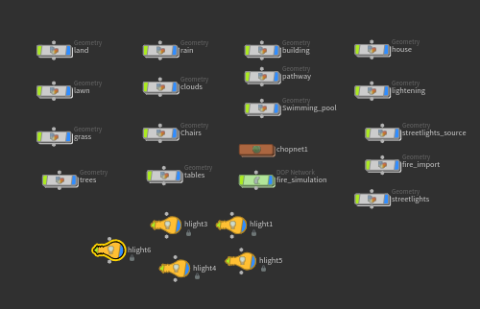

**Step-by-step Description:**

**1. Land:**

* To create the land, I have created a grid node and in parameter pane adjusted the size as 500 and rows and columns to 100.Then after created a color node to look the base color as sand or mud color so selected color parameter it to be as red color in parameter pane and then connected it to a transform node adjusted its uniform scale to 5.82 and translated it along y- direction about 20 and rotated it 90 degrees along y-direction.

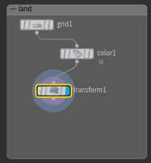 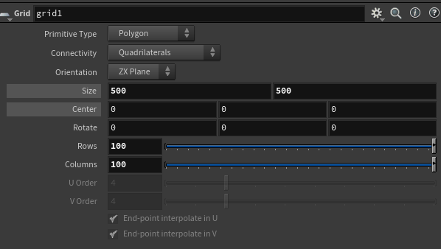

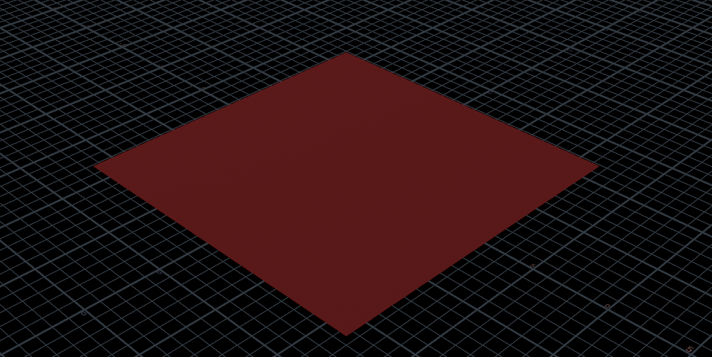

**2.Lawn:**

* In order to create lawn, I have used line nodes, 5 line nodes and merged them together using a merge node, I have set the direction of each line node in parameter pane in a different direction accordingly in order for them to look like a grass and adjusted their length to 10 and points 50.
* Then created the transform node and connected the output of merge node to this node and adjusted the parameter values of translate along y direction to -4, rotation along x axis to 101.203, y axis to -83.025 and uniform scale to 0.8 and then to add grass color created color node and connected the output of transform node to this node and in parameter pane selected green as color and then created a grid node adjusted it’s size to (2800,2800) and changed values of rows& columns to be as 100 and center along y-direction to 40 and then created copytopointsnode and connected the output of grid node to second input of this node and output of color node to first input of this node in order to create the copies of the grass to look like a lawn.

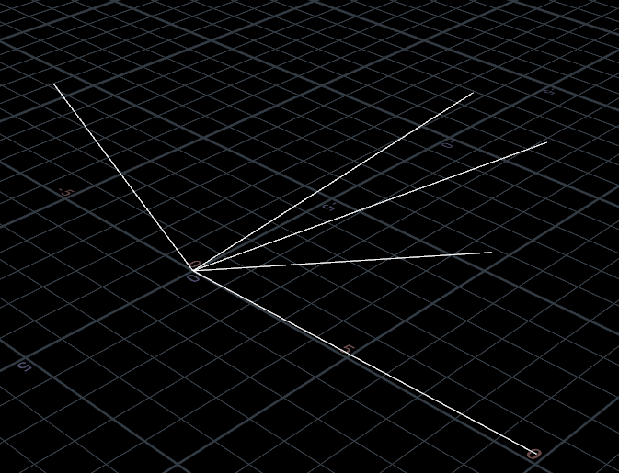 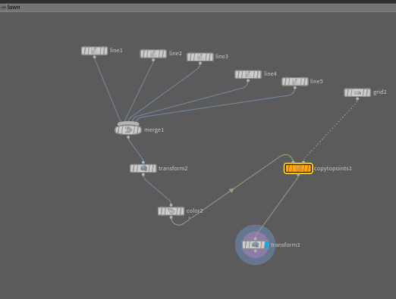

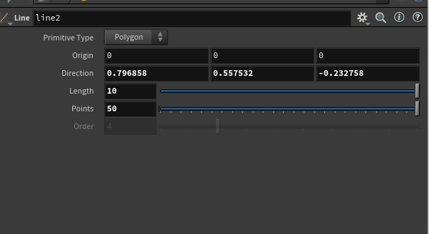 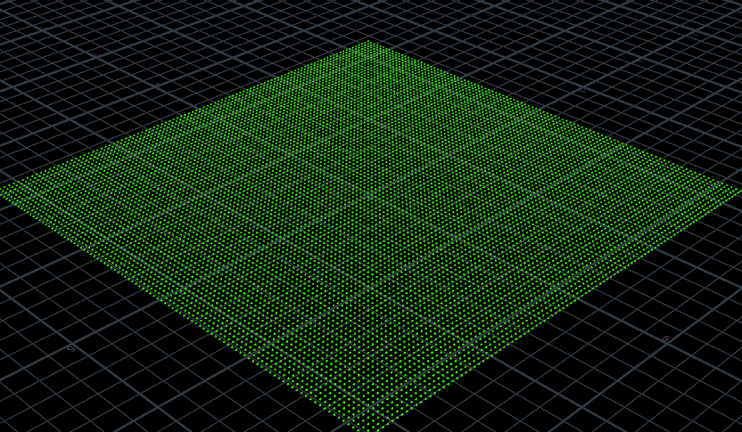

**3.Grass:**

* I created ‘5’ Line nodes and gave them vivid directions to give them the look of grass blades and to give it a better look I went further by creating curve node and manually drawing another ‘3’ grass blades with a slight curving bend in them and later merged all those nodes together using merge node as shown below.

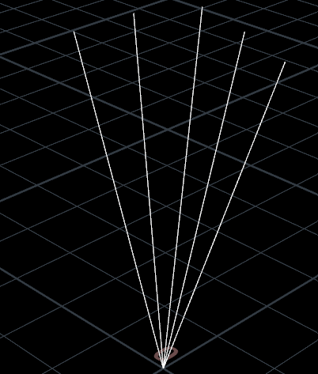 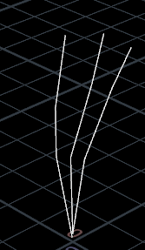 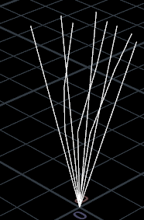

**Line node grass Curve node grass blades Merged both**

* Later, I went on and connected resample node to customize maximum segment lengths. The resample node is next connected to a Polywire node to give the line nodes thickness by giving wire radius ‘0.01’ for the grass blades and gave the objects color using color node. An image of grass after polywire and color node have been applied is shown below.

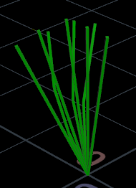

* Now, create a transform node and connect it to the color node, in parameter pane $F function is applied in the rotate section ($F%4*4, $F%4*3, $F%4*2) for giving the grass wind effect and to make those grass blades move and scaled it to 0.4. Now, I created a grid node and scatter node simultaneously and connected both to copytopoints node by parallelly connecting the transform node of grass blades which we have created before.

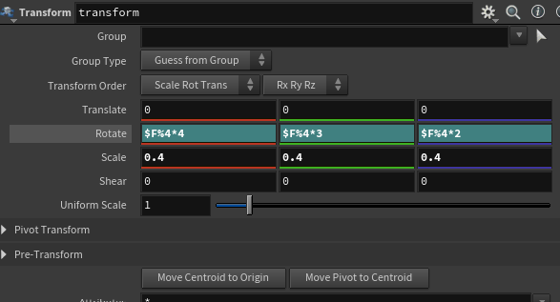

* For populating the grass, changes can be done in the grid node and scatter node anytime in the process. So, we can leave those nodes with any random parameters until we give them. But the finalized parameters are shown in the fig below.

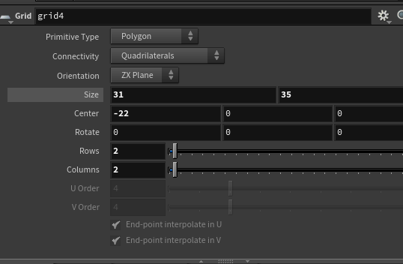 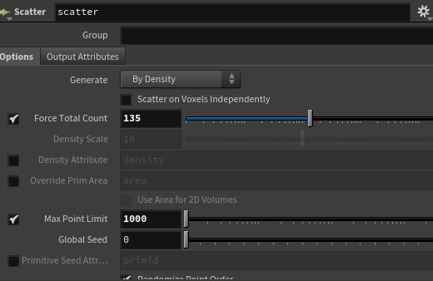

**Grid size for grass Force total count in scatter node**

* So, now when connected to copy to points node copies of grass blades gets placed according to the parameters given in the grid node and scatter node. Later, I created a transform node to change its position to suit the land grid I have changed its parameter of translate, scale and uniform scale to 10 accordingly and now turn on blue flag and click on animation play bar then we can the wind effect to grass.

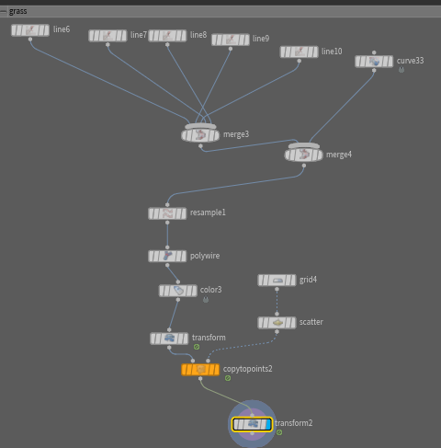 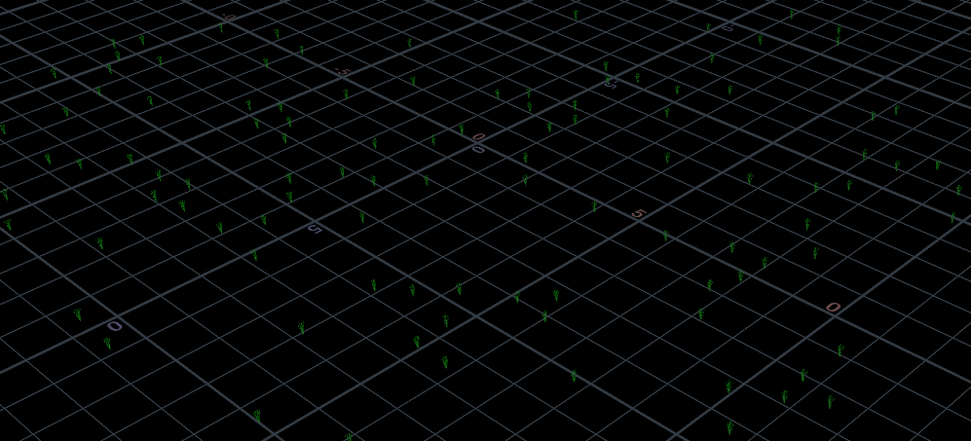

**4.Trees:**

* I have created a curve node and drew a branch like shape in scene view and simultaneously created a box node with a uniform scale of 0.2 and center along y axis to 0.9 and x-axis to 1.
* Now, connected a resample node to the curve node and decreased the maximum segment length to 0.36 to make it appear more curved. Now, connected both box node and resample node to Poly extrude node, select the group from which you want your curve to come out to form as a branch i.e., ‘4’ in the parameter pane adjusted the values of distance, inset, division as per need and from dropdown selected the spine shape option to curve from second input.
* Now connected color node to the Poly extrude node to give it a green color followed by revolve node where in this parameter pane adjusted the origin to 0.764645, 9, -0.135947 to make it revolve in x-axis and divisions as ‘10’ for no. of branches Connected output of this node to transform node and adjusted its rotation along x axis to $F%4*2 so that when wind hits it rotates along x direction just the leaves.

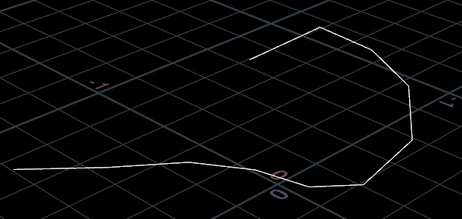 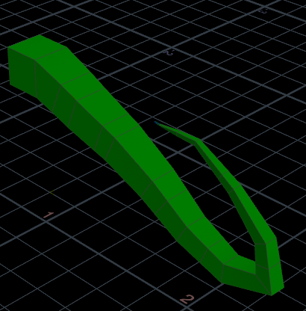

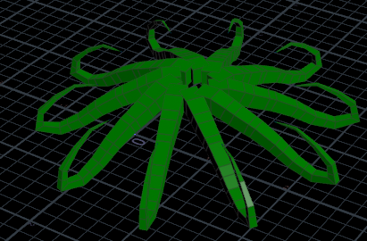

* For the trunk I created a tube node with primitive type as polygon and applied endcaps to it and adjusted the values of tube center, radius scale and height according to needs. changed its position according to the branches that I had created earlier. Connect the tube node to color node and select a color that suits trunk of a tree as brown.
* Then created a Merge node for both color node of tube node and revolve node of box node (trunk, branches) and connect a transform node to give it scope to be placed anywhere required and adjusted the translate parameter values along x,y,z -direction.

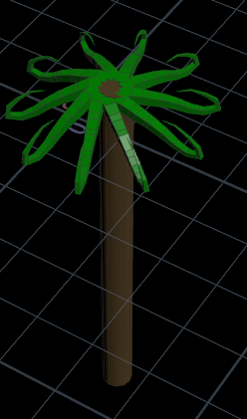 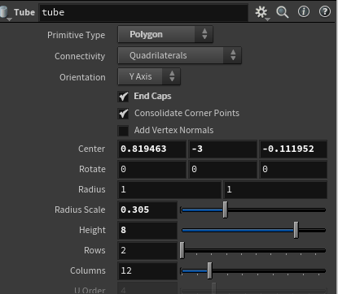

* After creating a single tree, for creating copies of the trees and placing them in one corner of the base land to look more attractive. I have used a copy node and connected it to the output of transform node and in parameter pane changed the total no.of copies to be 11 and then created another transform node for positioning of the trees by adjusting the translate parameter along x,y,z direction and uniform scale to 25.

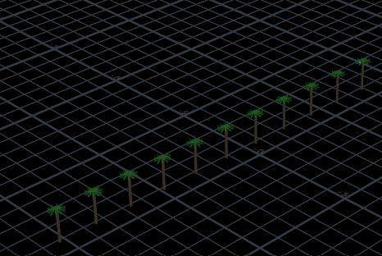 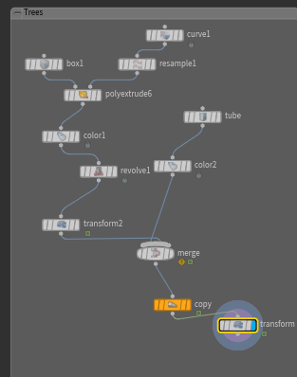

**5. Tables:**

* To create the tables in the lawn, table which has ‘top’ and ‘legs’, therefore, to create the top I have used the ‘grid node’ and set its size to (1,2).
* Then created a transform node and connected the output of grid node to input of this node to scale the position adjusted the translate, scale values accordingly in parameter pane.
* Now I have connected output of transform node to input of polyextrude node and adjust the distance parameter to extend the top.
* Now to create legs I have used the tube node, set it’s radius scale to ‘0.192’, height to ‘1.8’, center as (-0.1,-0.83) and then I had connected the tube node to the polyextrude node to look like table legs, so adjusted the distance to be ‘-0.389’.
* Now to create the copies of legs I have used the ‘copy to points’ node, the polyextrude node of the tube node is connected to the first input and the grid node (top) is connected to the second input of the copy to points node.

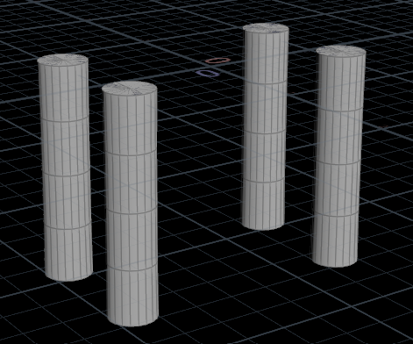

* To create a design on top of the table I have used another grid node with the same parameters as that of the top and connected it to the polyextrude node for applying the design, to do that I have set the ‘divide into’ option to individual elements and the inset to ‘0.247’.
* Then I merged it by connecting the output of the copytopoints, grid (tabletop), polyextrude node of both the grid nodes to the merge node then a table is created in scene view. Then I connected it to color node and selected a color to add it to table. I have used the transform node to place it in position accordingly by translating to (21.3,-4, 12.3) and uniform scale to 0.71

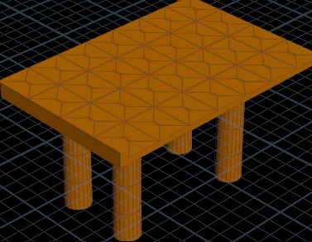

* To create Multiple tables I have used copy and transform node and selected total number of copies to be as 2 and translated it along x,y,z axis and adjusted scale to 9,8.7,9 and uniform scale to 3 and turn blue flag on then multiple tables have been created as shown in below image.

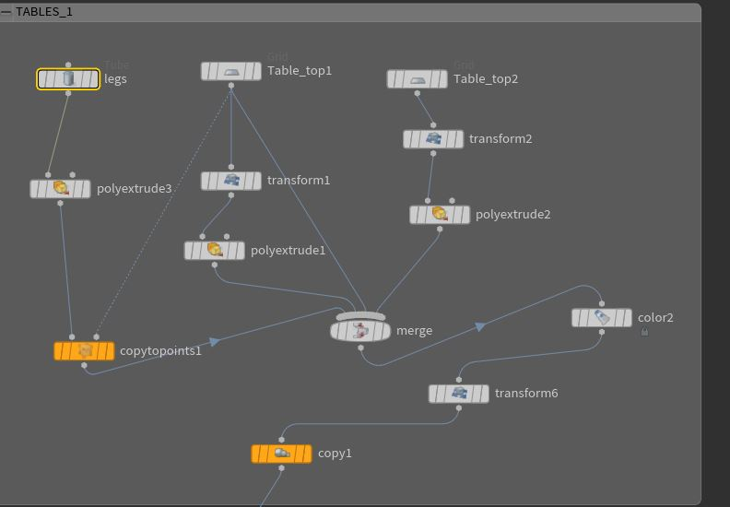 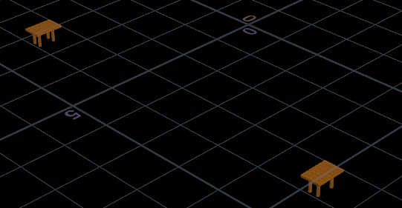

* Then created other two tables by following previous steps in addition changed the transform values accordingly as per needs. Hence four tables have created in scene view as shown in below image.

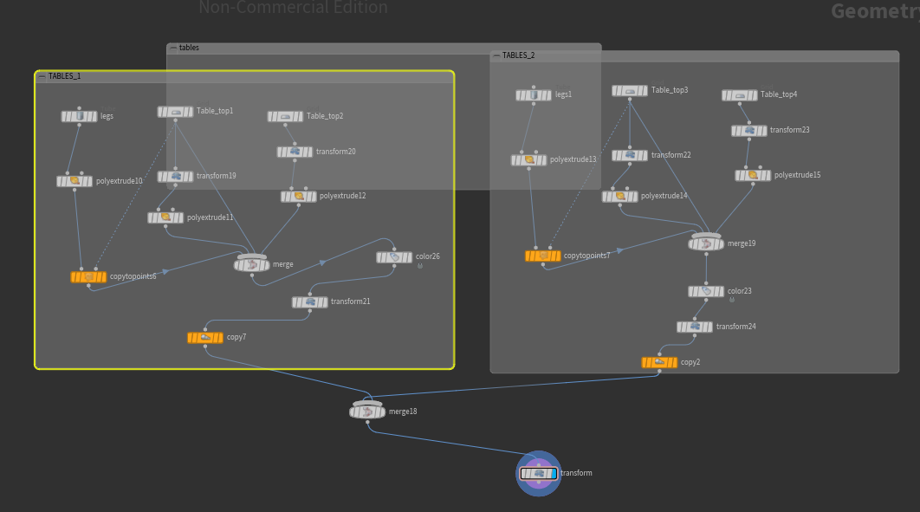

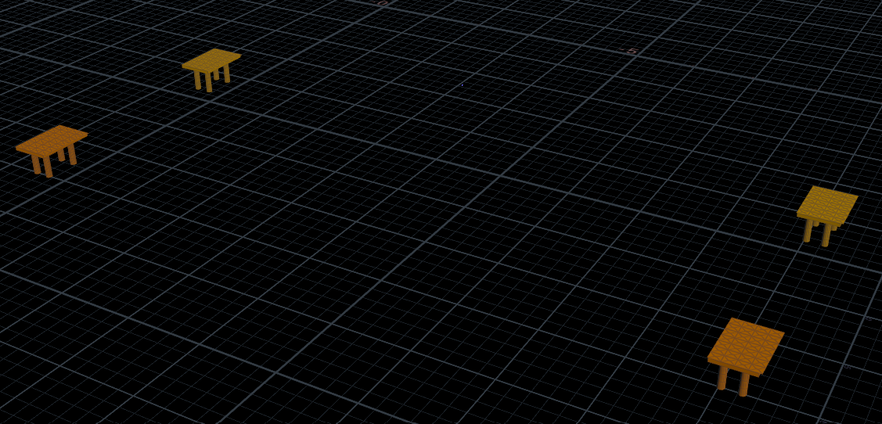

**6. Chairs:**

* To create the chairs, I have used ‘two grid nodes’, one for the seat and one for the back-support.
* Both grid nodes are set to same parameters i.e., their size is set to (2, 2) and the (rows, columns) to (2,2) and center along y direction to -1.
* Both these grid nodes are connected to two polyextrude nodes, their distance is set to ‘0.168’.
* Now to create their legs I have used ‘four tube nodes’ by keeping same radius scale, height and adjusted the center parameter for four legs accordingly. And enabled the end caps.
* Then I used merge node by connecting the output grid and tube nodes using the merge node. Now I have adjusted the position by creating a transform node by adjusting the translate, scale and rotation values accordingly.

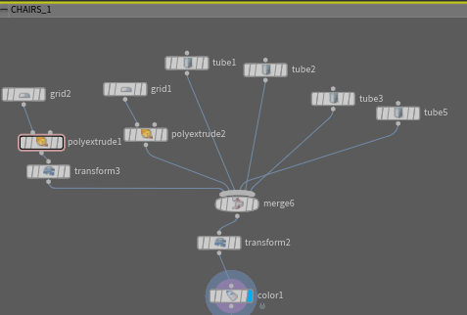 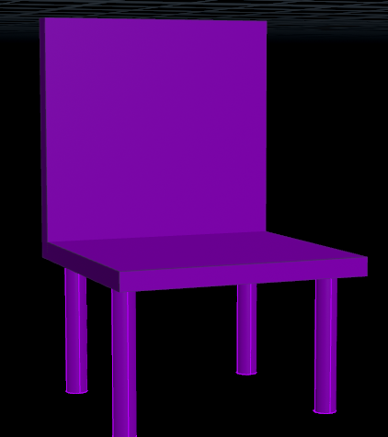

* Then I have connected it to a copy and transform node in order to create multiple chairs.

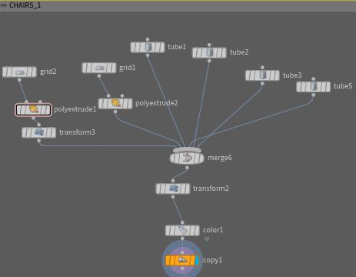

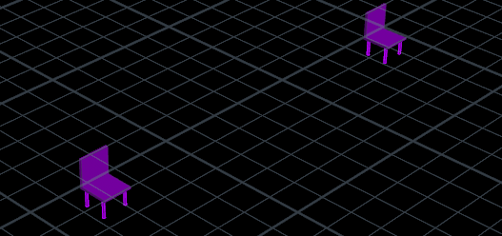

* Similarly, by following similar steps I have created total of 8 chairs by just changing the translation, rotation parameter values in transform node .
* Then connected merge node to show all the chairs created and these chairs are placed near the tables using the transform node by scaling the position values.

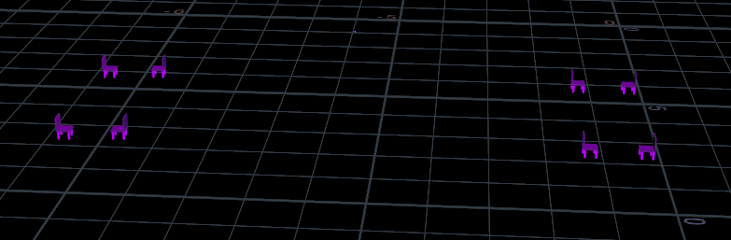

**7. Pathway:**

* Then created the pathway to walk inside the building and lawn, so used grid node and set the size of the grid to (7.5,100), and set it’s (rows, columns) to (2, 2), center to be (70,20.5,5.1) and rotation along y-direction to be 90.
* Then I connected it to the transform node to adjust its position accordingly to enter building by translating to (237.245, -172.983, 861.99) and uniform scale to 10.
* Then connected it to a color node to change its color suitable to a pathway, I have set it to black color.

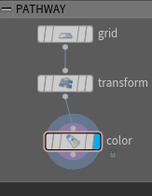 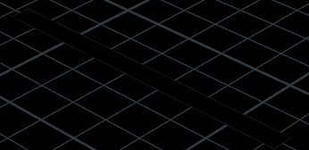

**8.Building:**

* To create building I have used a grid node by changing its size to (1,1) and rows & columns to 4.
* Connected it to a polyextrude node name it as wall 1 and in order to increase the height of building adjusted the distance parameter value to 2 and to show no.of floors of building I have adjusted the divisions parameter to 4 and disabled output front and inorder to create windows I have connected it to another polyextrude node selected divide into as ‘individual elements’ and adjusted the inset value to 0.06 and enabled frontgroup and then connected it to another polyextrude node selected group parameter to extrudefront and adjusted distance value as -0.04,inset to be 0.029, enabled front group then when we turn on blue flag we can view that windows have been created on the walls.

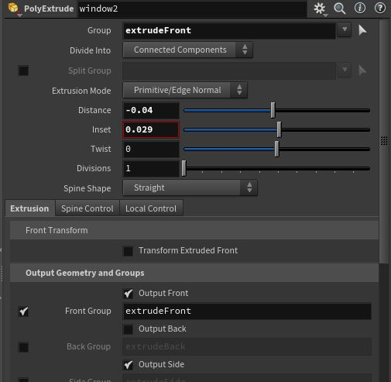 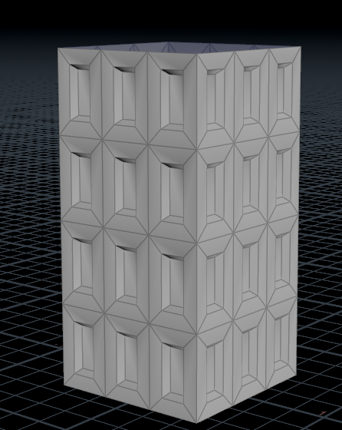

* Now to create top of the wall for building I have connected another polyextrude node (name it as wall 2) to grid node and kept distance, divisions values to be same as previous polyextrude node in addition I have just disabled the outputside.

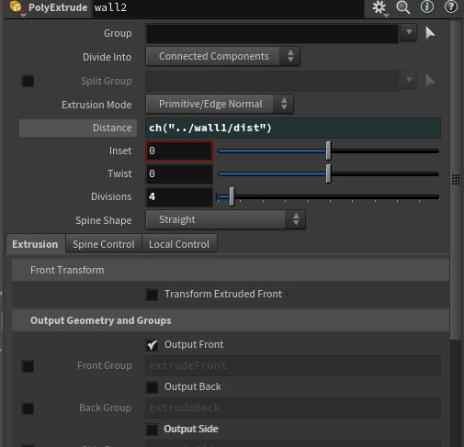 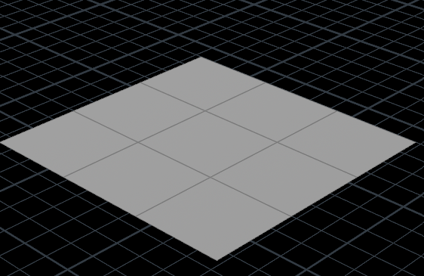

* No to make the top of the roof top to tear off ,I have connected output of this top wall Polyextrude node to first input of vellum constraints and in this parameter pane select constraint type to cloth and connected the output of this node to first and second inputs of vellum solver and in this parameter pane adjust start frame to 58 and in forces tab change the parameter of gravity along y direction to 0.5,built in wind to along x,y direction to -2 and built-in wind speed to 0.23 , built-in wind drag to 0.23 and connected first output of vellum solver node to switch node to make tear off at that particular frame number so in parameter pane changed the select input parameter to $F-57 .
* Then connected both window 2 node and switch node by using merge node I have connected output of wall 1 and wall 2.
* Now to color the windows I have used color node and selected the group to extruded front and color to be blue.
* Then to place it in required position have connected it to transform node and in parameter pane translated it to (-9,20, -3) adjusted its uniform scale to 15.

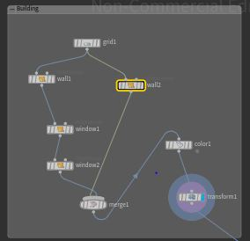 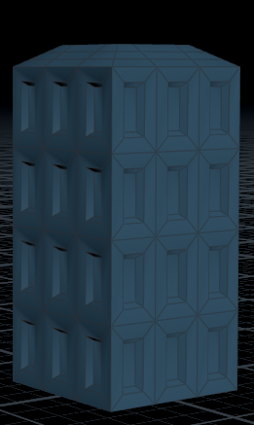

* Then to add name to the building I have used font node and in parameter pane select to Agency FB Bold font type and add text to SRAVANI ENCLAVE and connect the output of this node color node and selected color to red and connected it to a transform node to place this text on building wall accordingly and connected text and building transform node to a merge node and turn blue flag on to view building top tearing when wind hits or tornado effect in scene view.

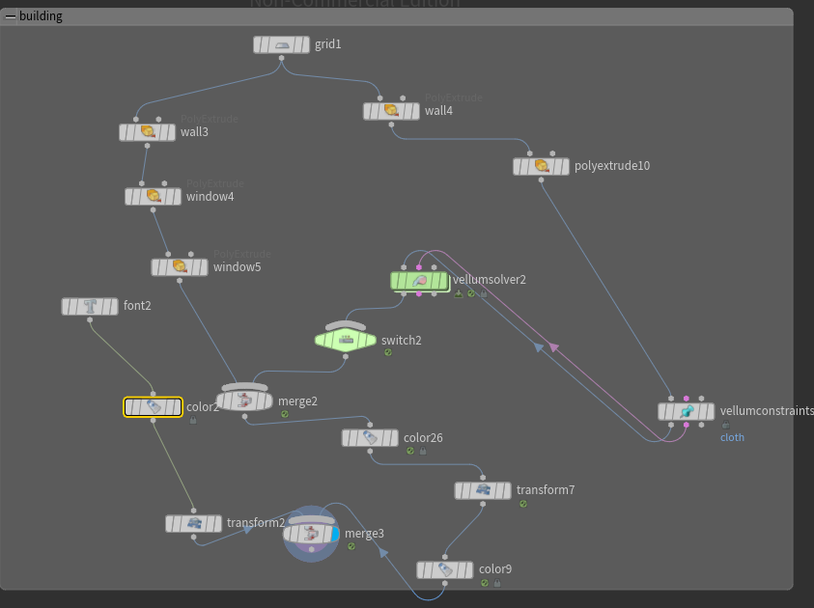

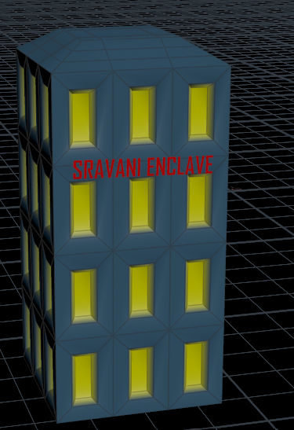

**Building roof top tearing off:**

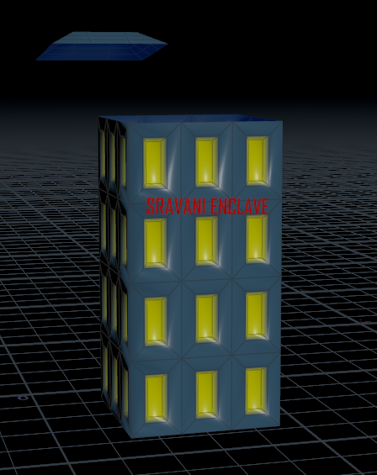

**9.Swimming pool:**

* Now to create I have created a base using grid node of size (180, 361.1150894165039), center as (14.3, 0.15, -64.6), rows and columns to 2.
* Then connected output of grid node to input of polyextrude node changed parameter of distance value to 9, inset to 10 ,enabled output back and then connect output of this node to transform node and in parameter pane changed its position, scale to 1,5,1,5,1 and uniform scale to 3 and then connect ouput of this node to input color node to look the base of it to blue .

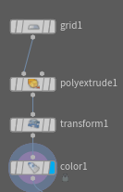 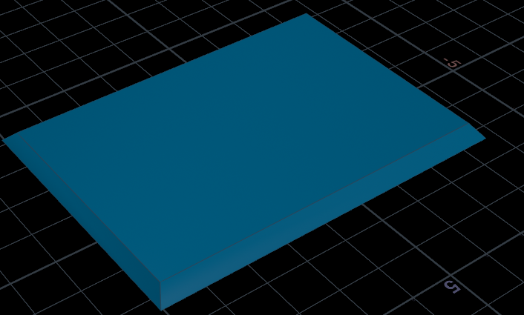

* Then to make the shape of water flow, I have created another grid of size (190,367), center to (13.712,1.676, -60.493), rows and columns to 300.
* Created ocean spectrum node and then connected output of grid and this node to ocean evaluate node and then connected this node to color node selected it as blue and connected it to a transform node to place the position of this waves on the base of grid node, scale to (1.5,1.5,1) and uniform scale to 3.

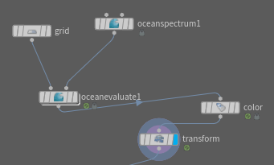 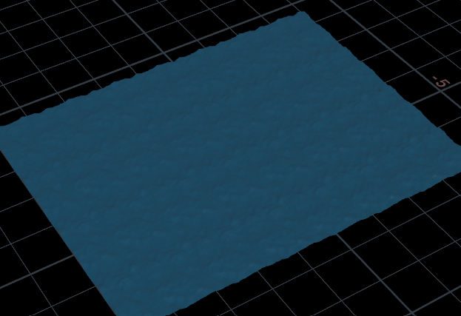

* Now merged both nodes to see the water flowing on to it connected output of base of the grid to the ocean wave node to input of a merge node and turn on blue flag and play animation bar to see the water flow.

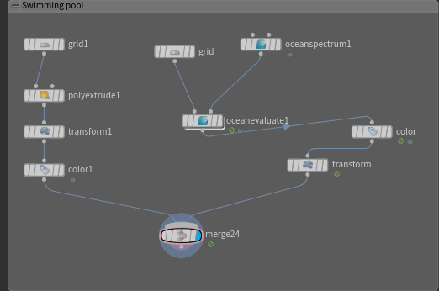

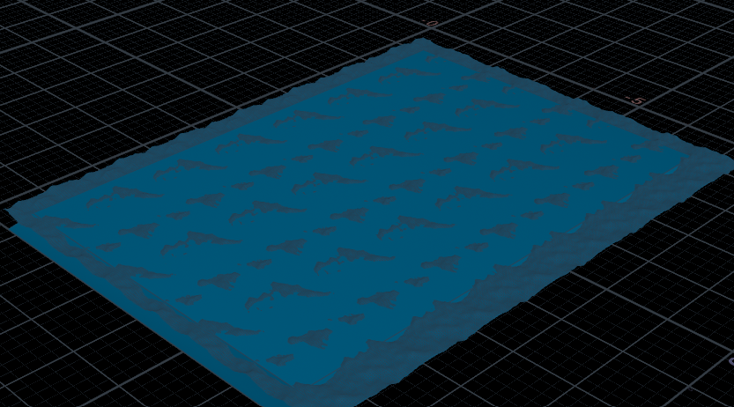

**10.Rain:**

* Created grid and in parameter pane adjusted size of (2800,2800),center to x axis to -36,y axis to 1200,z axis to -40,then connect output of this node to popnet node , divide in to this node and in that pop source node changed its color to white and in the birth tab changed value of constant birth rate to 200,life expectancy to 3.5 and in attributes tab selected initial velocity to add to inherited velocity and change velocity to y axis to -200 .

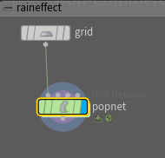 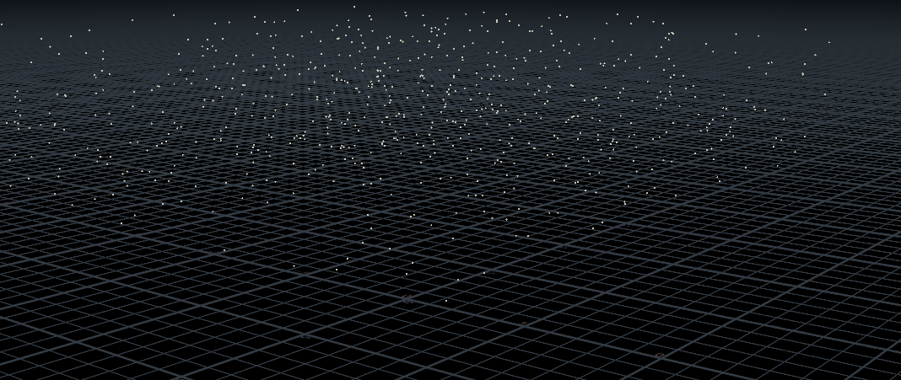

**11.Clouds:**

* Now to create clouds I have used sphere node and in parameter pane changed its radius, center position, uniform scale accordingly, then connected output of this node to input of mountain node and changed its amplitude value to 4.46 and then connected output of this node to input of cloud node in parameter pane changed its uniform sampling divs to 30,interior and exterior band voxels to 9 .
* Then created a grid node of size (1500,1500),adjusted its center position,rows to 4 and columns to 3, then connected ouput of this grid node and ouput of cloud node to copytopoints to make multiple copies of clouds and connected output of this node to color node and selected it as white ,turn blue flag we can see the clouds shape in scene view as seen in below image.

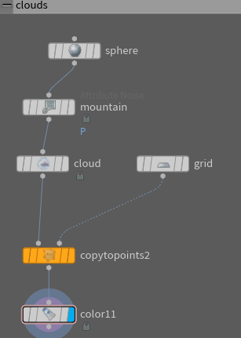 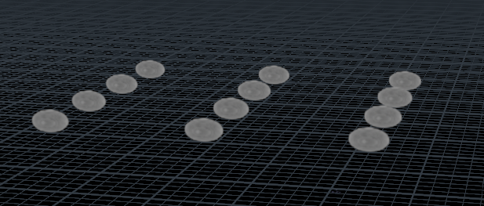

**12.Lightening:**

* Created an L-System node, this node is used to draw the series of the lines or used to create lightening effect and change the parameters of generations to 35 and random seed as $F for animation.
* Connected output of this node to input of transform node and adjusted it position, rotation, scale, uniform scale accordingly.
* Then to make the lightening effect to appear after rain at certain time I have used the switch node to set the frame number so I have change select input parameter to $F-25 and connected the transform node and null node to input of this node and if we turn on blue flag then we can view the lightening effect on scene view as in below image.

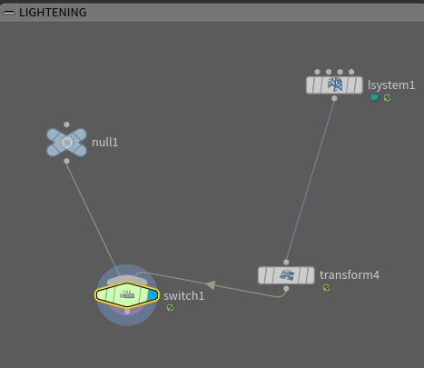 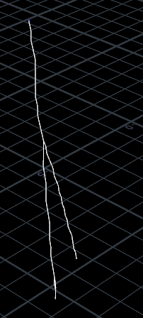

**13.Street lights:**

* Created 2 tube nodes to make look like electric poles where in the parameter pane of tube nodes adjusted their position, center, rotation, radius, radius scale and rows and columns accordingly. Then connected output of both tube nodes to input of merge node.

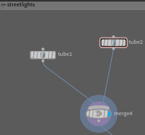 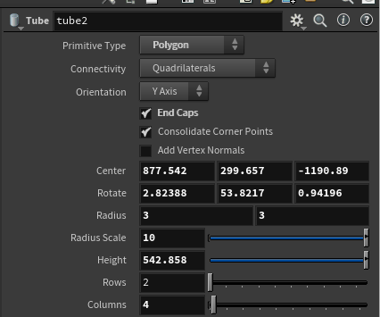 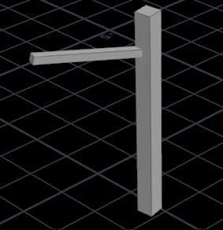

* And then connected this output of merge node to copy and transform node to create 2 electric poles, in parameter pane of copy node changed total number of copies to 2 and changed its position and rotated it along x axis to -2.42659.

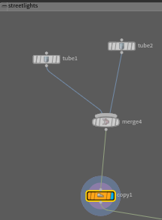 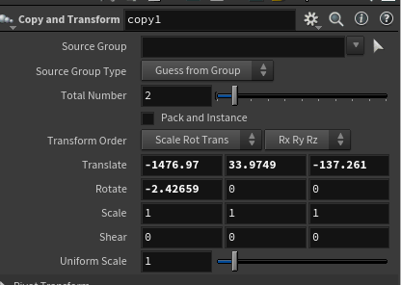 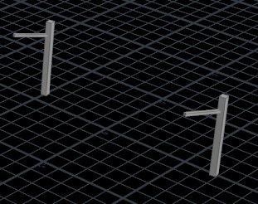

* Used line node to make it look like electric wire between the electric poles, and in line node parameter pane I have changed the values of origin, direction, length and number of points and connected the output of line node to input of copy node and changed its total number of copies to 6 and translated it along y direction to 15 .

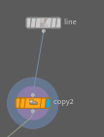 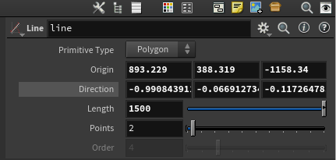 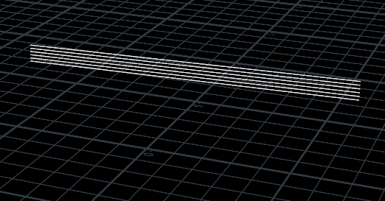

* Created a merge node to connect the poles and electric wires I have connected the outputs of both copy nodes and connected the output of merge node to input of color node and selected color to grey to look electric pole.

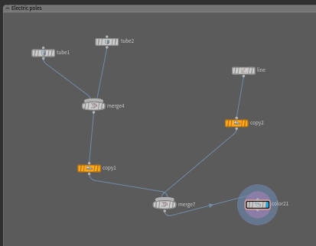 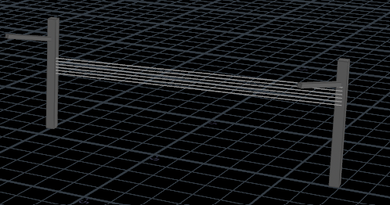

**When lightening strikes electric pole it creates fire so used spreading fire:**

* Then when lightning strikes this pole it creates fires, so for that I have used pyro nodes, I used spreading fire node it creates more realistic natural fire effects and smokes.
* On the Top bar collection of tools, select tab pyroFx and in that click on spreading fire and by pressing ctrl key LMB to select the fire to be seen, and we can see 3 nodes externally created in network pane those are fire simulation, fire import and source node automatically created after selecting spreading fire.
* Where fire simulation is Dop network and fire import for fire emission as we can see in the below image the fire spreads on the electric pole when lightening strikes.
* So dive into streetlight simulation and in that pyro source node change the particle separation to 12.019 and in box node adjust its position and uniform scale and in pyrosource spread node change start frame parameter value to 37 and radius to 36.057,element size to 160.254.In volume rasterize attributes node adjust voxel size to 4.50713.
* Then click on animation play bar so when lightening strikes this pole the fire spreads over electric pole.

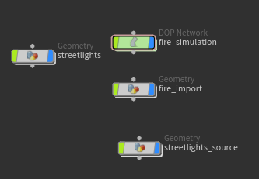 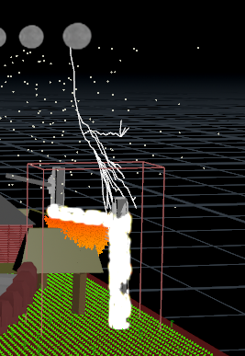

**14.House:**

* For house I will have used 4 grids so that to show each wall of the house different design, in grid parameter pane for 4 walls I have adjusted the size, position, rows to 20, columns to 10.Then connected output of all walls of grid node to make walls of house a design I used polyextrude node in that I have changed distance and inset parameters accordingly. And for the side 3 walls of the house I have connected the output of polyextrude node to input of the color node and selected different colors for all three side walls.

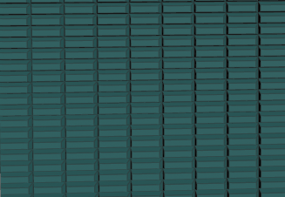 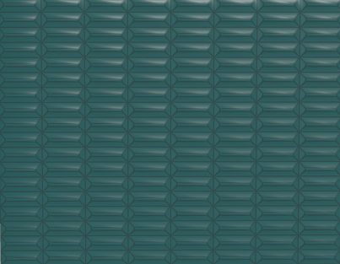 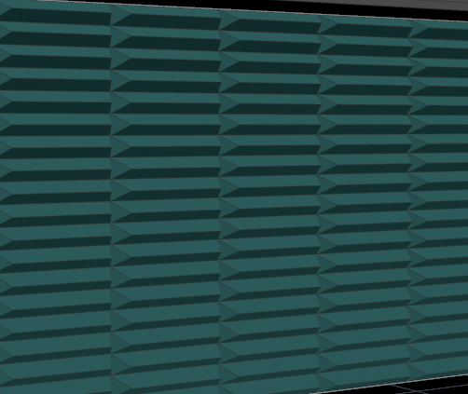

* So front face of the wall , I have created a house entrance by using box node and connected it to a Boolean node and in box parameter pane I have adjusted its size, center, uniform scale to 9.94 and in Boolean node subtracted it to make it a entrance of house .Then created another box node in parameter pane I have adjusted its size, center, uniform scale to 15 and connected it to Boolean node and subtracted it and then connected two output of boolean nodes to polyextrude node and adjusted it distance to 0.651 and connected output of this node to input of color node and selected a color .

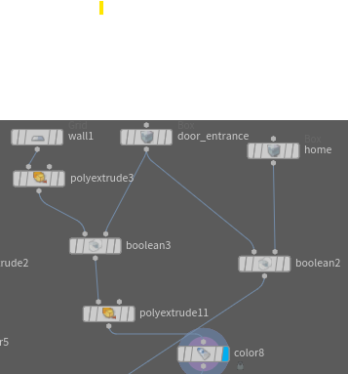 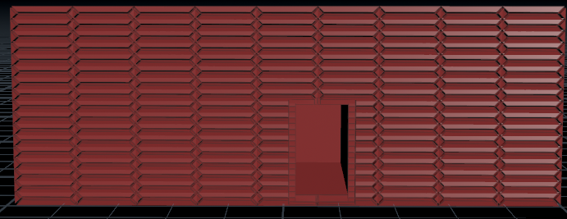

* To make roof top used grid node in parameter pane changed its size and position and then connected the output of this node to input of polyextrude node changed its distance, inset, twist, divisions, and enabled output back and connected output of this node to input of color node.

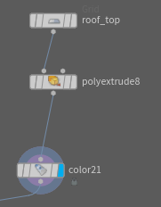 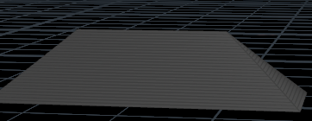

* To make vent of the house on top of it I have used 2 box nodes and in parameter pane adjusted size, position, uniform scale and connected output of this node to input of Boolean node to subtract the tube so that to appear hole of vent and connected to color node selected color to grey.

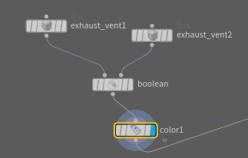 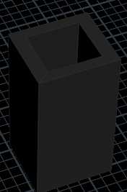

* Connected all 4 walls of house, rooftop, and vent of the house to input of merge node and then to transform node to scale the position accordingly, so that we can view house in scene view as in below image.

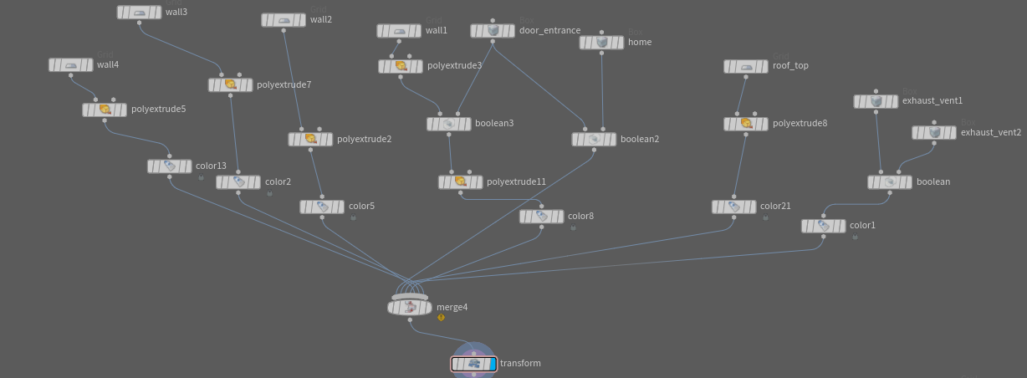

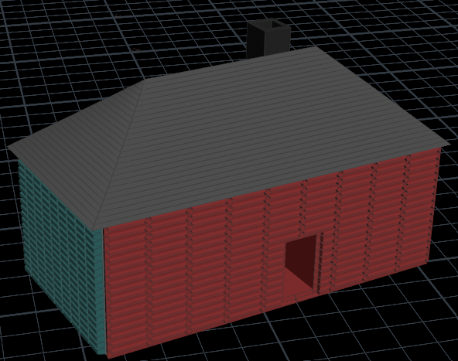

* Then to create a base foundation to place house on top of it I have used grid node and changed its parameters of size, position, rotation and then to make legs for it I have used tube node in that parameter pane I have adjusted values of position, radius, height to 18,rows to 2, columns to 4 and then to create 4 corners like pillars I have used copytopoints node by connecting outputs of grid and tube node and then connected it to a merge node and connected it to transform node to adjust position and then to a color node selected brown color to look like wood color base .

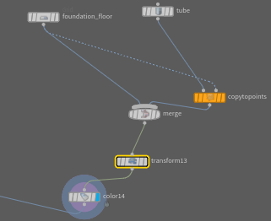 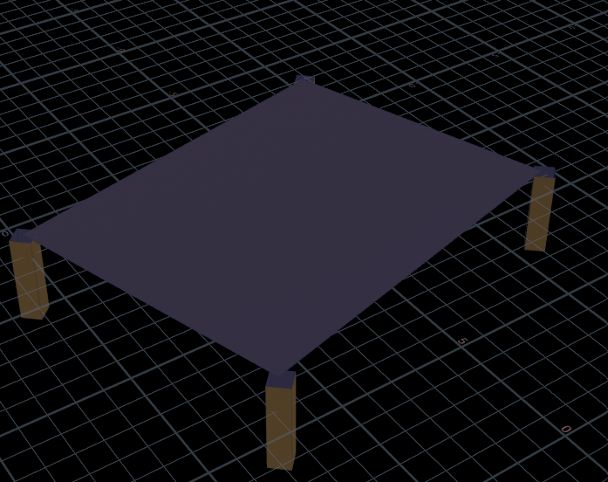

* Then to make deck to house I have used grid node of size (8,8), rows and columns to 9 and to select 4 corners of the wall dynamically, used 4 group nodes connected input of those 4 group nodes to grid node and for group1 node in parameter pane add base group parameter values as 0-`(chs("../grid1/rows")-2)*(chs("../grid1/cols")-1)`:`chs("../grid1/cols")-1`,now if we see the scene pane one vertical side have been selected, for group2 node add base group parameter values as `chs("../grid1/cols")-2`-`(chs("../grid1/rows")-1)*(chs("../grid1/cols" 1)-1`:`(chs("../grid1/cols")-1)`,for group3 node add base group parameter value as 0-`chs("../grid1/cols")-2' and for group4 node add base group parameter value as `(chs("../grid1/rows")-2)*(chs("../grid1/cols")-1)`-`(chs("../grid1/rows") 1)*(chs("../grid1/cols")-1)-1` and then after create another node called merge and connect output of those 4 group nodes to input of merge node , and then next create another node polyextrude and connect output of merge node to input of this polyextrude node and in parameter pane add group parameter values as “group1 group2 group 3 group 4” and in

scene pane it shows walls created. Now suppose if we want to make entry to that house i.e space between walls, go to group3 node as it’s starts at first corner as 0 so we can use that wall and to create a space in-between we use keyword ^ along with column value to add space , so in parameter pane add base group parameter value as 0-`chs("../grid1/cols")-2`^3, this results in single space in between walls of grid. Suppose if we want to add extra space just add base group value a 0-`chs("../grid1/cols")-2` ^3-4 and this results in a house that allows peoples or extra space between walls as shown in below image. Then connected output of polyextrude node to input of color node and then connected this node to transform node to scale its position accordingly.

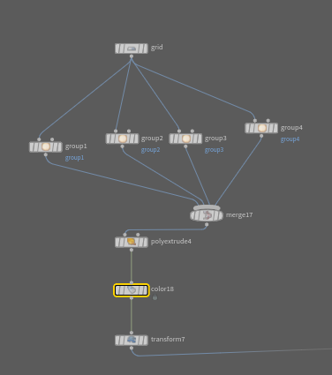 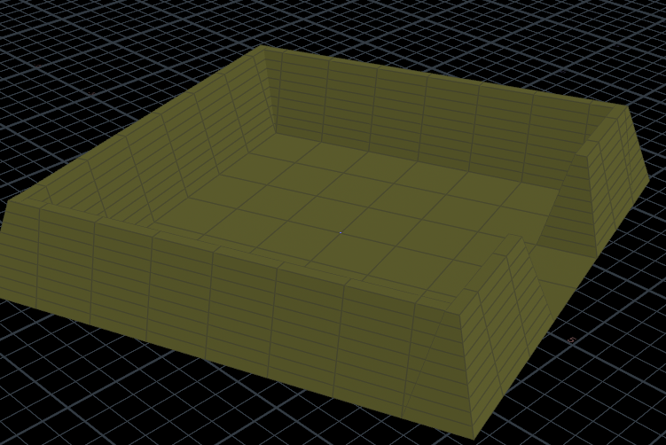

* Now to create a stair Create tube node and enable end caps & adjust values of center,radius,radius scale &height acc. to needs in parameter pane and then create a color node to color the tube and then connect output of tube node to this node & choose any color from parameter pane ,then we can view a pillar of that staircase in scene view.

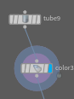 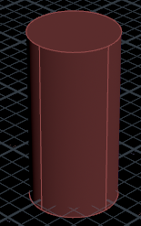

* Now to create bricksteps we need to first create a box node name it as brickstep and in parameter pane select primitive type of box as mesh and also adjust the values of size, center, rotate & uniform scale acc. to needs and then to create bricksides i.e as railing need to create another box node name it as brickside and in parameter pane select it primitive type as polygon mesh and also adjust the values of size, center, rotate & uniform scale acc. to needs and then create another polyextrude node to polyextrude top face of the brickside and connect output of brickside node to this node and in parameter pane adjust values of distance & inset and set group value to be 2 i.e select top face and then create a color node to color the brickside name it as color 2 and connect the output of polyextrude node to input of this node and choose any color in parameter pane and then create a merge node and connect the output of brickstep and color nodes to input of this merge node then we can view a single brickstep with brickside is created .

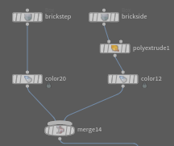 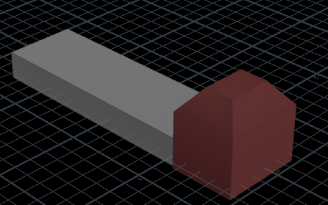

* Then after create transform node and connect output of merge node to this node and adjust values of position, rotation acc. to needs and then create copy node to view multiple stairs connect output of transform node to this node and in parameter pane adjust total number parameter as 6, translate, rotate acc. to needs then we can see multiple stairs.

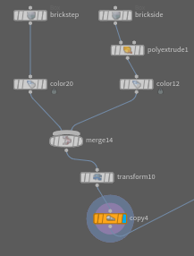 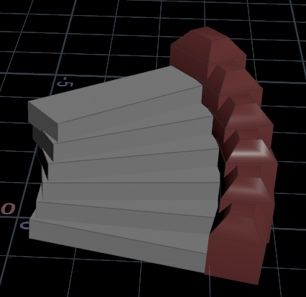

* Finally to view staircase create another merge node and connect of color1 and copy node to input of this node and then used transform node to adjust its position, rotation, uniform scale to 10 and turn on blue flag then we can view a staircase in scene view as shown in below image.

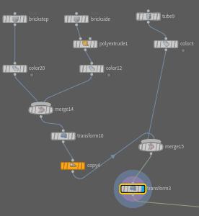 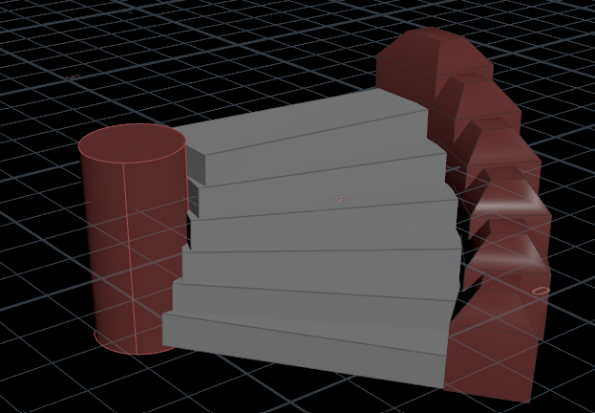

* Then connected outputs of base, deck, staircase, house to input of merge node then we can view house completely and then connected it to transform node adjusted its position accordingly.

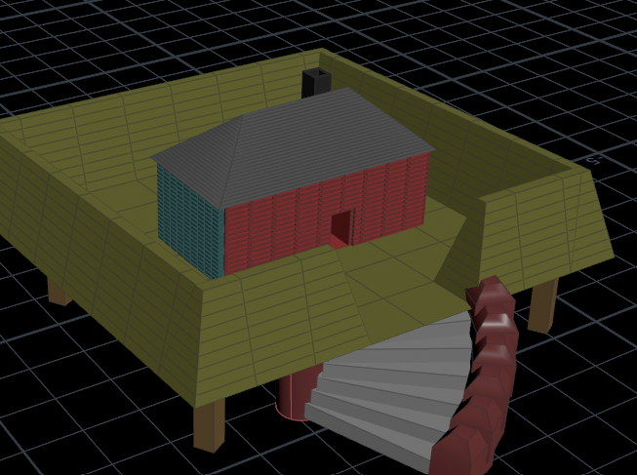

**When lightening strike electric pole fire spread to House,so to make it fire used popnet node:**

* Then created a grid node of size (25,25), adjusted its position, rows and columns to (50,50),then connected it to popnet node and dive into that node and in popobject set creation frame as 48,in popsource node in birth tab change parameter values of impulse count,max points per frame to 810,seed to 3.8,life expectancy to 3.2,life variance to 1.59 and in attribute tab select initial velocity to set initial velocity set velocity in y direction to 100,varaiance along x,z direction to 75 and y to 0.
* Then connect output of popnet node to input of color node in parameter pane select color type to ramp from attribute adjust its color to look like fire .

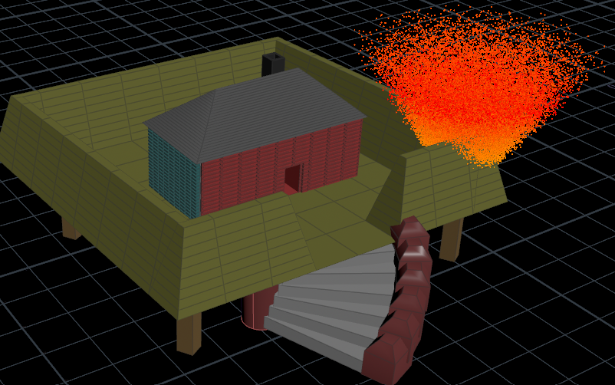

**15.Audio(Chopnet):**

* So to add audio as thunder rain effect sound I used chopnet node in object level and dive into that node create a file node in network pane and in parameter pane select channel file parameter select audio file to upload click on select from folder and accept then click on motionfxview on top of scene view we can view the audio track waves in scene view.
* On the bottom of the animation bar there are two tabs where first tab is parameters of motion i.e select that global animation options window in that check Realtime playback and select maintain realtime playback possibly skipping frames then click om animation bar then it plays audio according to time frameset .Then after click on speaker phone tab it will bring audio panel go to scrub tab enable mono tab then go to chop option choose operator click on chopnet and select audio file to upload and then after click on play button on animation bar then we can hear audio then click on animation play bar then audio plays in the background.

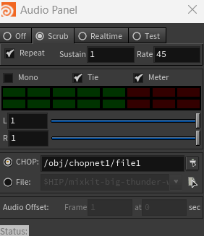 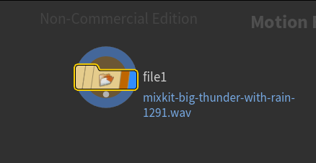

**16.Pointlights:**

* Point lights are fundamental in 3D rendering because they help create realistic lighting effects and shadows in virtual scenes.
* In the scene view, on top pannel we can create light effect by selecting point light node
* On top pannel from lights and cameras tab select point light node which displays Light icon/widget -circle with rays coming out move the cursor to scene view and place the light node anywhere we like or press ctrl +left mouse button to click to place the light at the default position.
* You see the light node with handles in the scene view. Also it creates a network node pointlight at object level as usual. This is similar to the shape of light bulb Place it anywhere. It comes with orientation handles adjust it on scene view.

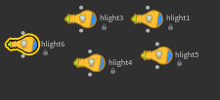

**FINAL PROJECT LOOKS LIKE:**

**Before Lightening :**

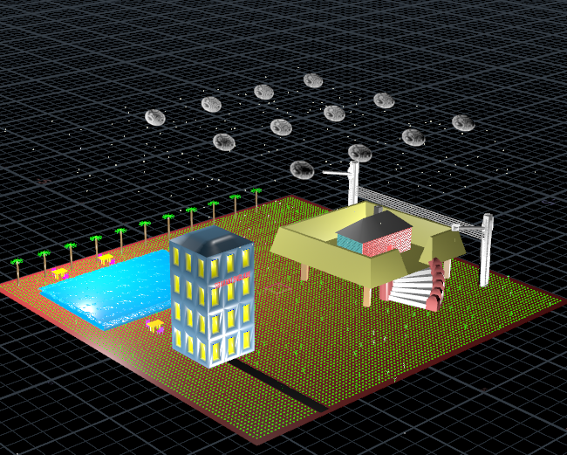

**After lightening hits electric pole:**

